Yellow Starthistle

Background
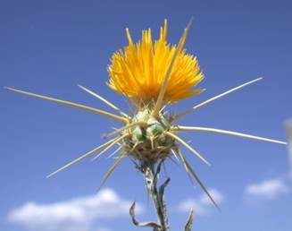
Yellow starthistle, Centaurea solstitialis, is native to Eurasia. It is believed to have come to the US via South America. It is now common in open areas on roadsides, rangeland, wildlands, hay fields, and pastures. Disturbances created by cultivation, poorly timed mowing, road building and maintenance, or overgrazing favor this rapid colonizer. It forms dense infestations and rapidly depletes soil moisture, thus preventing the establishment of other species. It is also poisonous to horses, causing a nervous disorder called “chewing disease” (nigropallidal encephalomalacia), which is fatal once symptoms develop. Horses are the only animal known to be affected in this manner and should not be allowed to graze on yellow starthistle.
Description
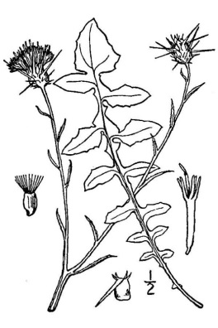
Yellow starthistle is a gray-green to blue-green plant with a deep, vigorous taproot. It produces bright, thistlelike yellow flowers with sharp spines surrounding the base. Yellow starthistle grows to heights varying from 6 inches to 5 feet. The stems of mature plants are rigid, spreading, and typically branching from the base in open areas. Stems and leaves are covered with a loose, cottony wool that gives them a whitish appearance. Stems appear winged due to leaf bases that extend beyond the nodes. Basal leaves are 2 to 3 inches long and deeply lobed. Upper leaves are short (0.5 to 1 inch long) and narrow with few lobes.
Impacts
The Yellow star-thistle plant has the ability to create monotypic stands and habitats in the cultivated soil of fields, graded dirt sites, and disturbed natural ecosystem lands. Its colonization eliminates and prevents other plant species from growing, terminating the habitat's biodiversity. Extensive spreading monotypic fields of yellow starthistle are not uncommon. Its growth plasticity, competitiveness, preference for the Mediterranean climate, and a lack of natural herbivore enemies and co-evolved species, make it a very successful invader. The plant is an invasive pest in field crops, degrades native plant habitats and natural ecosystems, prevents the grazing of domestic animals in rangelands, and is a physical barrier to native wildlife.

